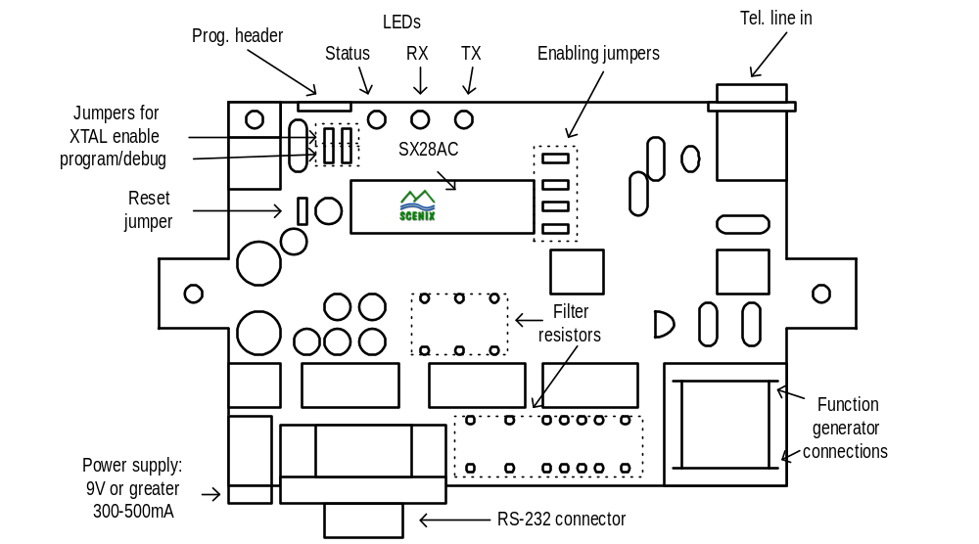Preparing the Scenix V.23 Origination Sales Kit

  - Load resistors, jumpers, and SX28AC into sockets
  - Load filter resistors into filter resistor sockets
    - Load R39 and R43 sockets with 2.80k resistors
    - Load R26, R27, R28, R29, R44, R45, R46, and R47 with 5.62k resisters
  - Load all jumpers
    - Put jumpers on all of the enabling headers
    - 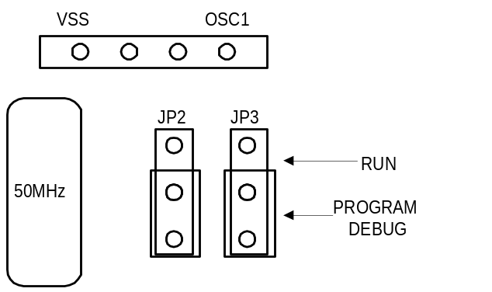Place jumpers in program/debug position (JP2, JP3)
  - Load SX28AC with pin 1 on bottom, left corner
Program SX28 with V.23 Origination Software
  - Place SX-Key on the programming header. VSS of SX-Key goes on left side of header.
  - Apply power with 9V or greater power supply
  - Open SX-Key software
  - Open most recent software from CD Contents directory
    - Example:
\\Appslab4\c\Marketing & Applications\VP's\CD contents\V.23 Source Code\v_23_originate_1_35_rev_2_1.SRC
  - Select <Program> from <Run> menu
    - If device doesn’t program, make sure SX-Key is connected to a comm port of the computer.

- Test V.23 Origination board using the function generator
  - Remove power from board
  - Move program/debug jumpers to XTAL enable position (JP2, JP3)
  - Remove SX-Key
  - Put serial cable onto the RS-232 connector
  - Connect serial cable to comm port of PC
  - Open Hyperterminal
    - Hyperterminal Settings: 1200bps, 8 data bits, 1 stop bit, hardware flow control
    - Ensure that comm port setting matches the comm port that the modem is connected to
  - Apply power to board
    - Prompt should appear with AT-Command instructions
      - If garbage appears, double check hyperterminal settings
      - If nothing appears, double check modem board connections or restart computer and re-open Hyperterminal.
  - Connect function generator to transformer on board
    - Connect red output from function generator through a 680 ohm resistor to one of the function generator connection points
    - Connect the black output from the function generator directly to the other function generator connection point
  - Set up the function generator for 1300 and 2100Hz FSK with a modulation rate of 600Hz at 50mVpp
    - Use the <shift>, <menu> keys to get into the modulation menu and change the FSK frequency to 2100Hz and the FSK rate to 600Hz.
    - Exit the menu and set the main output frequency to 1300Hz
    - Decrease the signal amplitude to 50mVpp
  - In the hyperterminal window, type ATDT and press <enter>
    - The modem should pause for 4 seconds and then output “DIAL”
    - About 10 seconds later, the modem should output “CONNECT 1275”
    - The modem should output a continuous string of U’s. Example:
“UUUUUUUUUUUUUUUUUUUUUUUUUUUUU...”
    - If there are some errors, then the modem fails this test. Increase the amplitude on the function generator until no errors are seen at the output. Mark on the bottom of the modem the level required.

- Test the modem board’s output capabilities
  - Connect the modem to a phone jack, on which another phone is connected
  - Pick up the other phone
  - Choose a number to dial and listen to the phone to ensure that the modem dials the right number and that the signal strength is the same as a known good modem
  - If the modem dials OK, then this modem is good.

- Preparing the Sales Kit
  - The Sales Kit should include:
- Hardcopy of V.23 Quickstart Guide
\\Appslab4\c\Marketing & Applications\VP's\CD contents\Quickstart.PDF
- Hardcopy of V.23 Originate Mode Appnote
\\Appslab4\c\Marketing & Applications\VP's\CD contents\V_23_org_doc_0_992.pdf
- V.23 CD-ROM Containing the contents of this directory:
\\Appslab4\c\Marketing & Applications\VP's\CD contents
- Use the computer at the back right of the lab (appslab 4) and use the Easy CD Creator software
- Label the jewel case for the CD-ROM
- Telephone cable
- 9V power supply
- Fully Tested Scenix Modem Demonstration board
- 9-pin male-female serial cable
  - Label the Sales Kit. You are done!

